Experiment Number: 1
Simulation and Comparative Analysis of FDMA, TDMA and CDMA: Resource Allocation, User Capacity and Mobile-Generation Context
Aim :
To simulate and compare the basic resource-allocation methods used in FDMA, TDMA and CDMA, and examine how their assumed user capacity and interference behaviour differ.
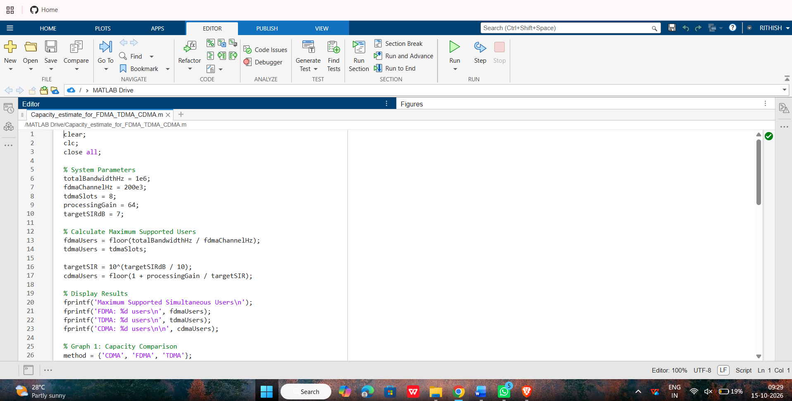
Objectives :
1. Model how FDMA, TDMA and CDMA allocate communication resources among users.
2. Plot how estimated CDMA SIR changes as the number of simultaneous users increases.
3. Relate the access methods to representative mobile generations and interpret the limits of the simplified model.
Program 1 — Capacity estimate for FDMA, TDMA and CDMA
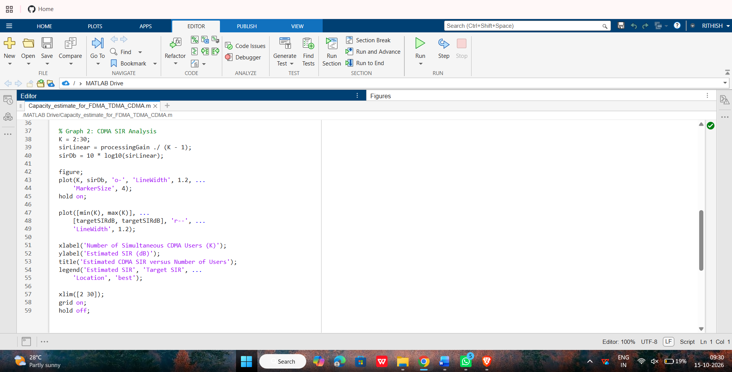
Objective 1: To estimate and compare the illustrative number of users supported by FDMA, TDMA and CDMA using the specified system parameters.
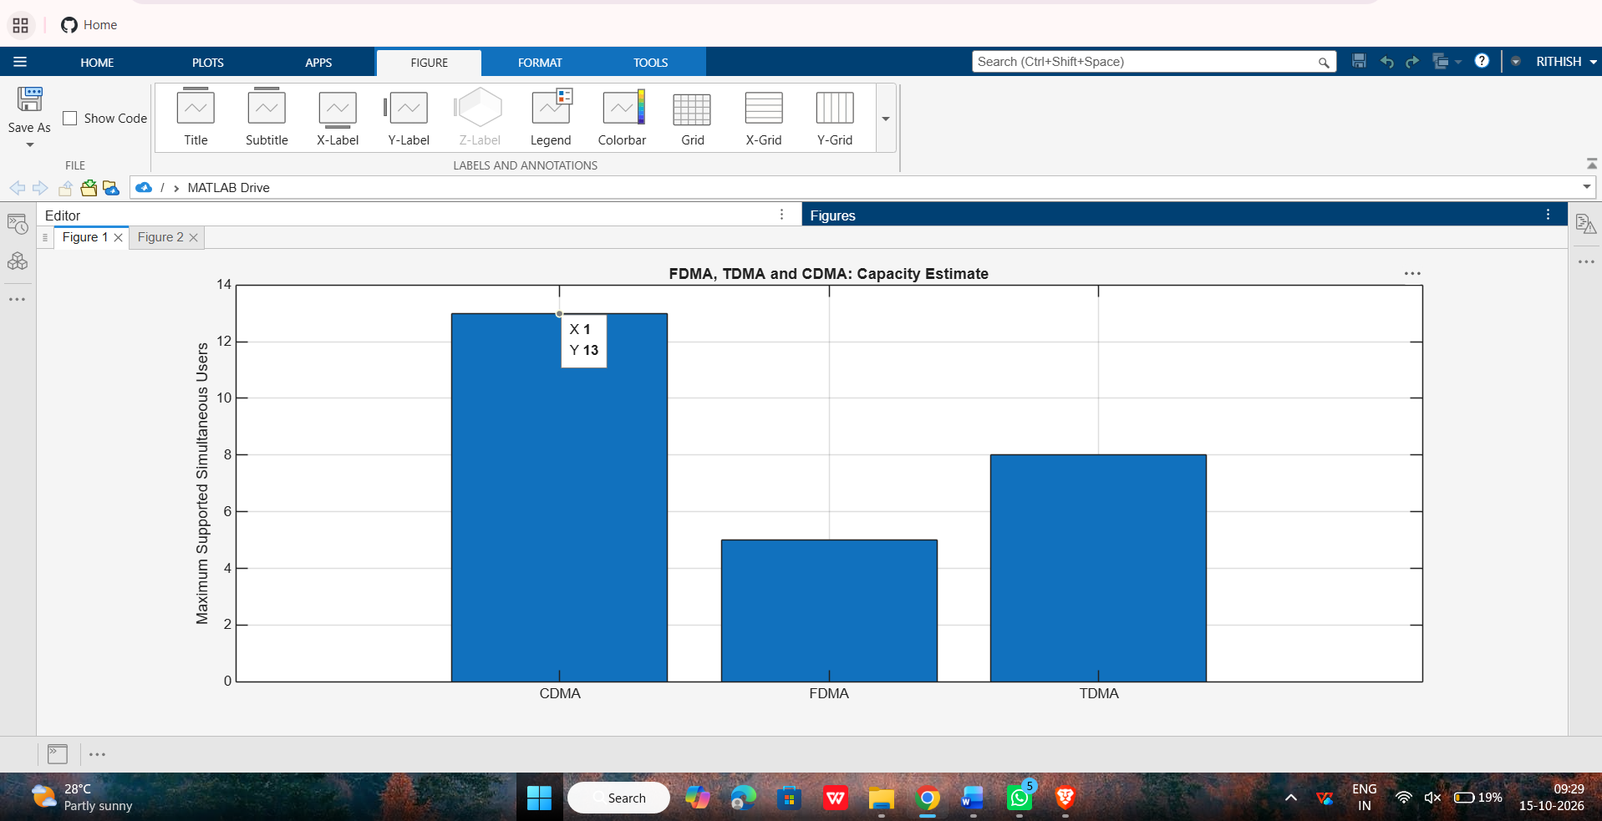

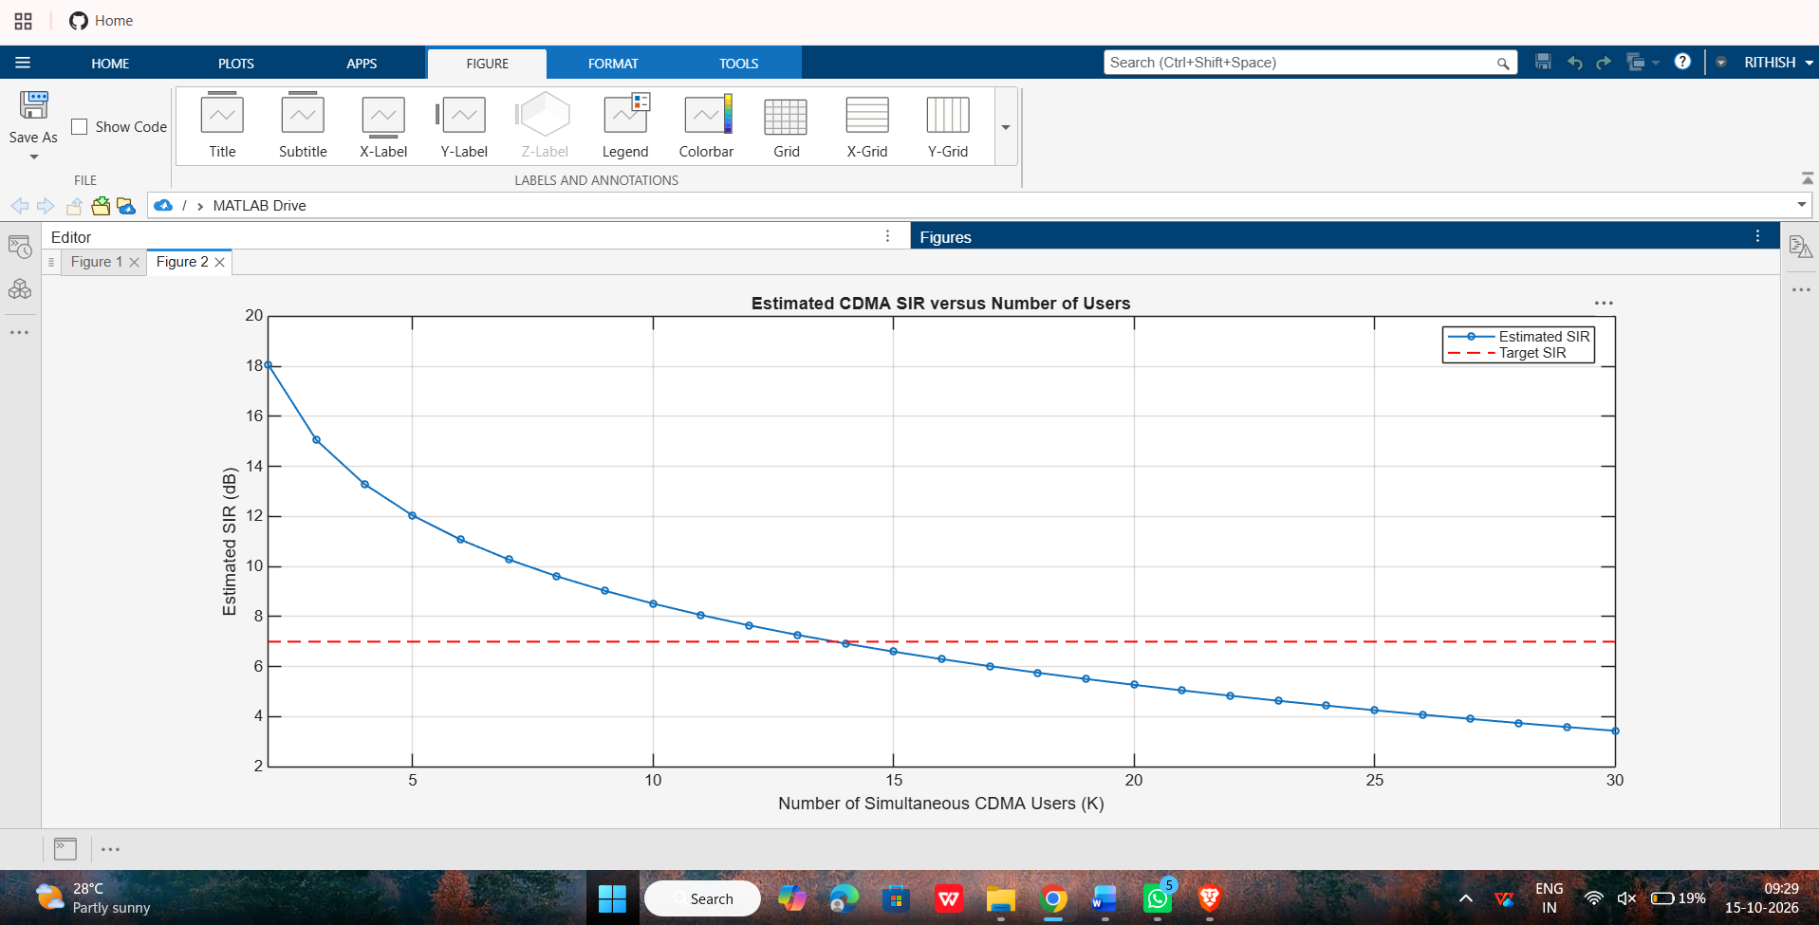
Objective 2: CDMA SIR analysis: To analyze how the estimated CDMA signal-to-interference ratio changes as the number of simultaneous users increases.
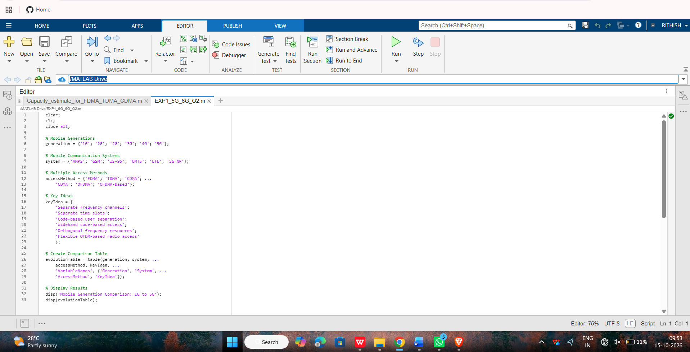
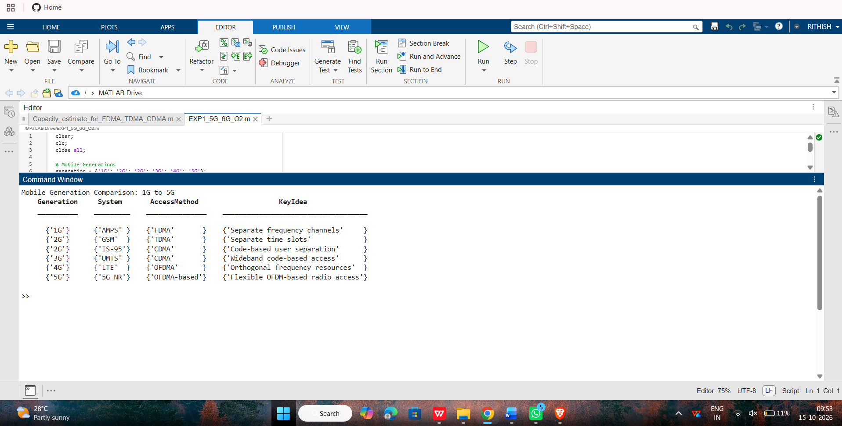
Objective 3: Mobile-generation comparison: To relate representative multiple-access techniques to the evolution of mobile communication systems from 1G to 5G.
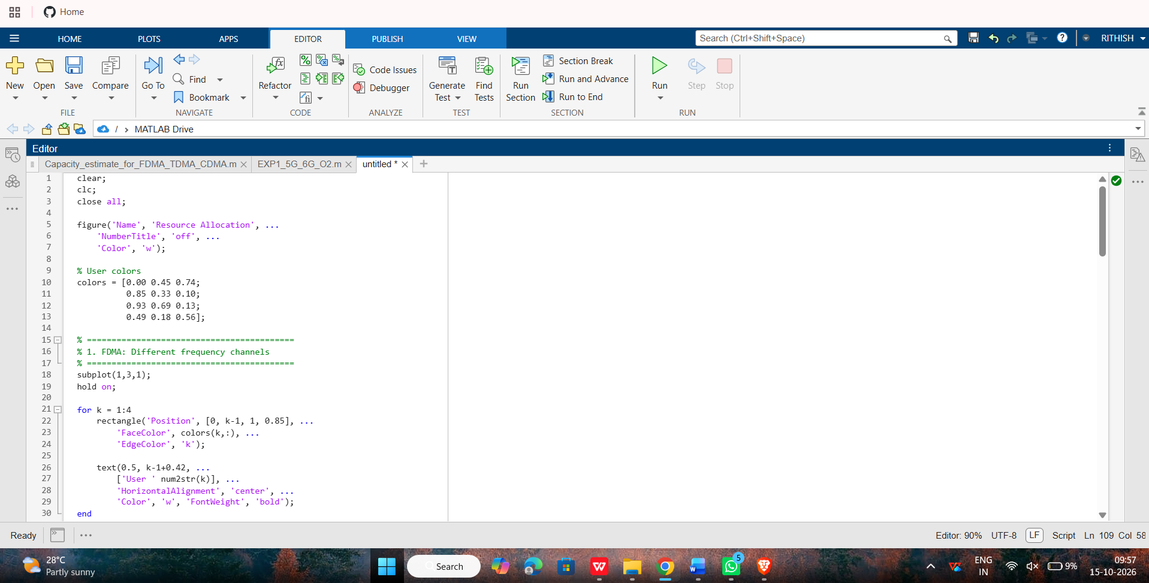
Objective 4: Resource-allocation diagrams: To visualize how FDMA, TDMA and CDMA assign frequency, time and code resources to multiple users.

